DEPARTMENT OF COMPUTER SCIENCE AND ENGINEERING

DIGITAL SYSTEM DESIGN LABORATORY (CS P33)

B. Tech – III SEMESTER

STUDENT NAME: MOHAMED B SIRAJUDDEEN
REGISTER NO: 22TD0053


RAJIV GANDHI COLLEGE OF ENGINEERING AND TECHNOLOGY
(Approved by AICTE and Affiliated to Pondicherry University)
ISO 9001:2015
PUDUCHERRY – 607 403
NOVEMBER 2023
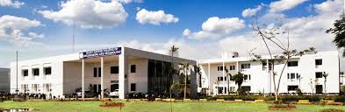

DEPARTMENT OF COMPUTER SCIENCE AND ENGINEERING
DIGITAL SYSTEM DESIGN LABORATORY (CS P33)
B.Tech – III SEMESTER

STUDENT NAME: MOHAMED B SIRAJUDDEEN
REGISTER NO: 22TD0053



RAJIV GANDHI COLLEGE OF ENGINEERING
AND TECHNOLOGY
(Approved by AICTE and Affiliated to Pondicherry University)
ISO 9001:2015

PUDUCHERRY – 607 403

NOVEMBER 2023

